**Task 8: Mobile Testing**

**Setting up the environment:**

**1)**

**Start the appium server**

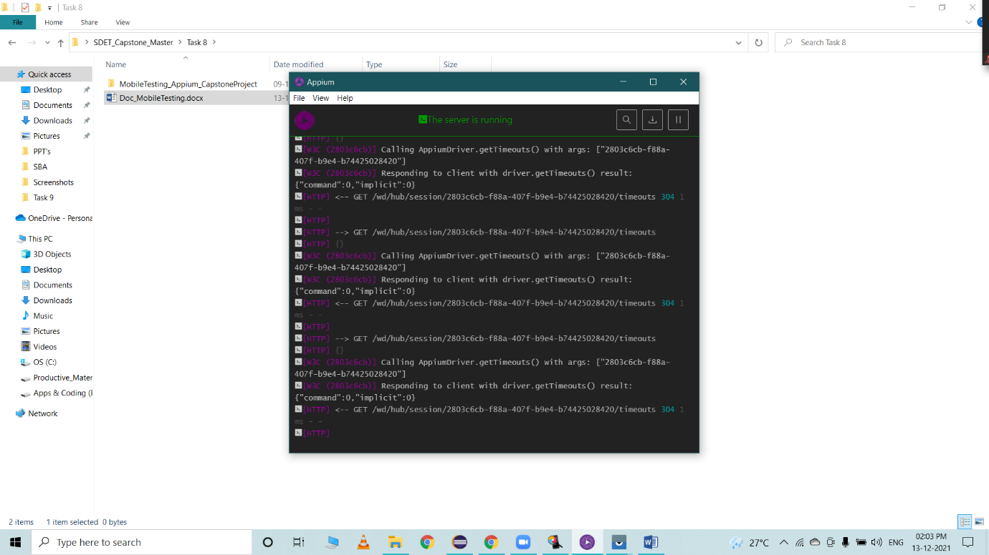

**2)**

**Open Vysor of connecting phone to adb driver**

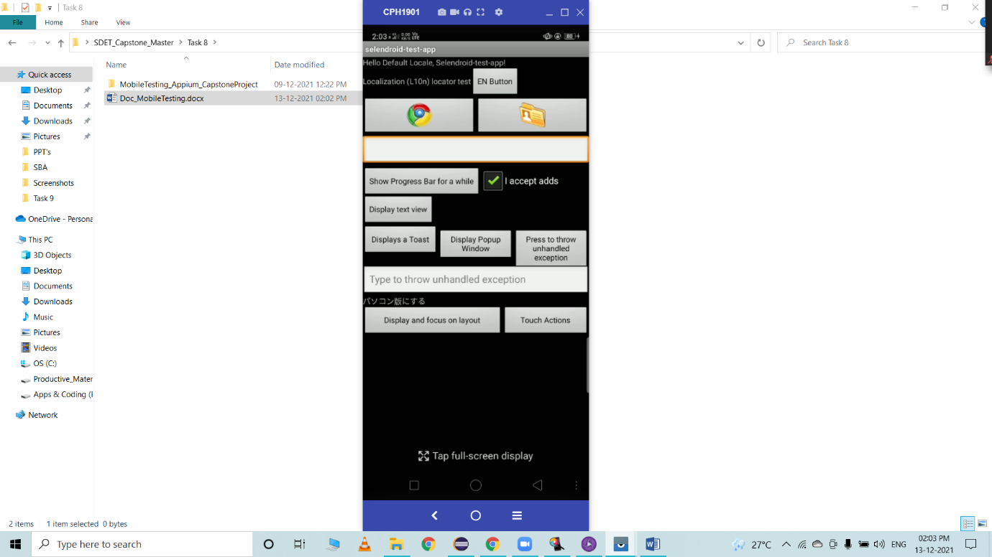

**3)**

**Launch Appium inspector to inspect the desired element**

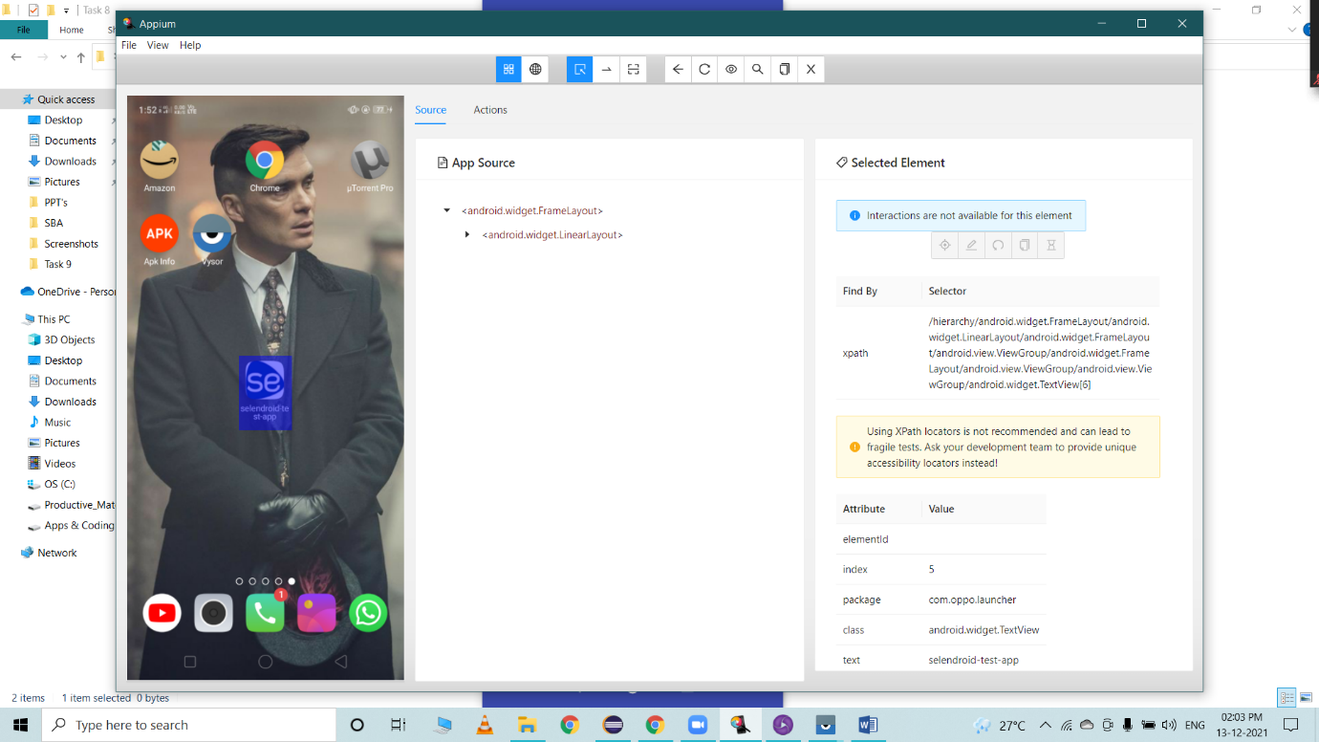

**Java – Selenium code:**

**import java.net.MalformedURLException;**

**import java.net.URL;**

**import java.time.Duration;**

**import org.openqa.selenium.Dimension;**

**import org.openqa.selenium.WebElement;**

**import org.openqa.selenium.remote.DesiredCapabilities;**

**import io.appium.java_client.TouchAction;**

**import io.appium.java_client.android.AndroidDriver;**

**import io.appium.java_client.remote.MobileCapabilityType;**

**import io.appium.java_client.touch.WaitOptions;**

**import io.appium.java_client.touch.offset.PointOption;**

**public class SelendroidAppTest {**

**public static void scroll(AndroidDriver<WebElement> driver)**

**{**

**TouchAction action =new TouchAction(driver);**

**Dimension size =driver.manage().window().getSize();**

**int start_x=(int) (size.width*.5);**

**int start_y=(int) (size.height*.5);**

**int end_x=(int) (size.width*.5);**

**int end_y=(int) (size.height*.3);**

**action.press(PointOption.point(start_x, start_y))**

**.waitAction(WaitOptions.waitOptions(Duration.ofSeconds(1)))**

**.moveTo(PointOption.point(end_x, end_y)).release().perform();**

**}**

**public static void main(String[] args) throws MalformedURLException, InterruptedException {**

**DesiredCapabilities dc = new DesiredCapabilities();**

**dc.setCapability(MobileCapabilityType.AUTOMATION_NAME, "Appium");**

**dc.setCapability(MobileCapabilityType.PLATFORM_NAME, "Android");**

**dc.setCapability(MobileCapabilityType.PLATFORM_VERSION, "8.1.0");//Version is number here**

**dc.setCapability(MobileCapabilityType.DEVICE_NAME, "OPPO A7");**

**//dc.setCapability(MobileCapabilityType.APP,"C:\\Users\\heman\\Downloads\\selendroid-test-app-0.17.0.apk");**

**URL url = new URL("http://127.0.0.1:4723/wd/hub");**

**AndroidDriver<WebElement> driver = new AndroidDriver<WebElement> (url, dc);**

**driver.findElementByXPath("/hierarchy/android.widget.FrameLayout/android.widget.LinearLayout/android.widget.FrameLayout/android.view.ViewGroup/android.widget.FrameLayout/android.view.ViewGroup/android.view.ViewGroup/android.widget.TextView[6]").click();**

**Thread.sleep(3000);**

**driver.findElementById("io.selendroid.testapp:id/my_text_field").sendKeys("Play games");**

**System.out.println("Typing in search bar");**

**Thread.sleep(2000);**

**driver.findElementById("io.selendroid.testapp:id/input_adds_check_box").click();**

**System.out.println("Removed the check on item");**

**driver.findElementById("io.selendroid.testapp:id/input_adds_check_box").click();**

**System.out.println("checked on item again");**

**Thread.sleep(2000);**

**driver.findElementByXPath("//android.widget.Button[@content-desc=\"showToastButtonCD\"]").click();**

**System.out.println("say hello selendroid");**

**Thread.sleep(2000);**

**driver.findElementById("io.selendroid.testapp:id/startUserRegistration").click();**

**Thread.sleep(2000);**

**driver.findElementById("io.selendroid.testapp:id/inputUsername").sendKeys("Hello world");**

**Thread.sleep(1000);**

**driver.findElementById("io.selendroid.testapp:id/inputEmail").sendKeys("Helloworld@gmail.com");**

**Thread.sleep(1000);**

**driver.findElementById("io.selendroid.testapp:id/inputPassword").sendKeys("Helloworld@gmail.com");**

**Thread.sleep(1000);**

**driver.findElementById("io.selendroid.testapp:id/input_preferedProgrammingLanguage").click();**

**Thread.sleep(1000);**

**driver.findElementByXPath("/hierarchy/android.widget.FrameLayout/android.widget.FrameLayout/android.widget.FrameLayout/android.widget.LinearLayout/android.widget.LinearLayout[2]/android.widget.ListView/android.widget.CheckedTextView[4]").click();**

**System.out.println("Selected python");**

**Thread.sleep(2000);**

**scroll(driver);**

**System.out.println("Scroll down");**

**driver.findElementById("io.selendroid.testapp:id/input_adds").click();**

**Thread.sleep(1000);**

**System.out.println("Register and proceed");**

**driver.findElementById("io.selendroid.testapp:id/btnRegisterUser").click();**

**Thread.sleep(1000);**

**System.out.println("Confirm and return to home page");**

**driver.findElementById("io.selendroid.testapp:id/buttonRegisterUser").click();**

**}**

**}**

**Output:**

